Practice - Stream ADLS diagnostic logs into stream analytics

Step 1 - Create ADLS, Stream analytics, Event Hub Namespacce (Create an eventhub).

Step 2 – ADLS -> Diagnostic Settings -> Blob Service -> Diagnostic Setting -> Choose what operations you want to track and destination – storage in storage or stream to eventhub.

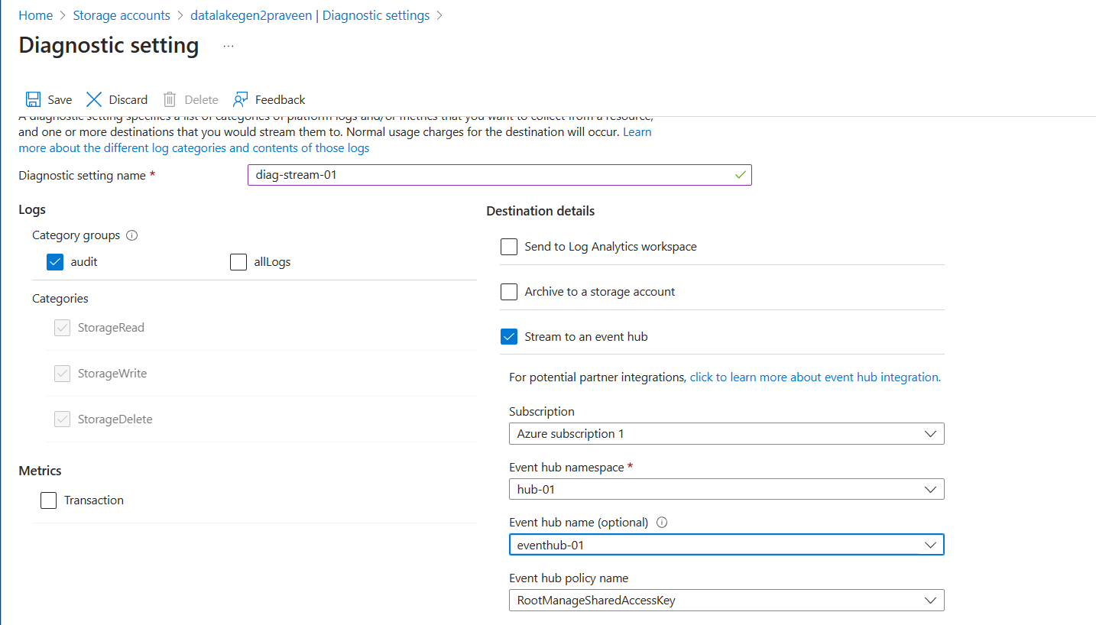

Step 3 – Add Event hub Input alias to Stream Analytics and create output alias as ADLS

Step 4 – Start the Streaming Analytics service

Step 5 – Perform Create/delete/read transactions in ADLS.

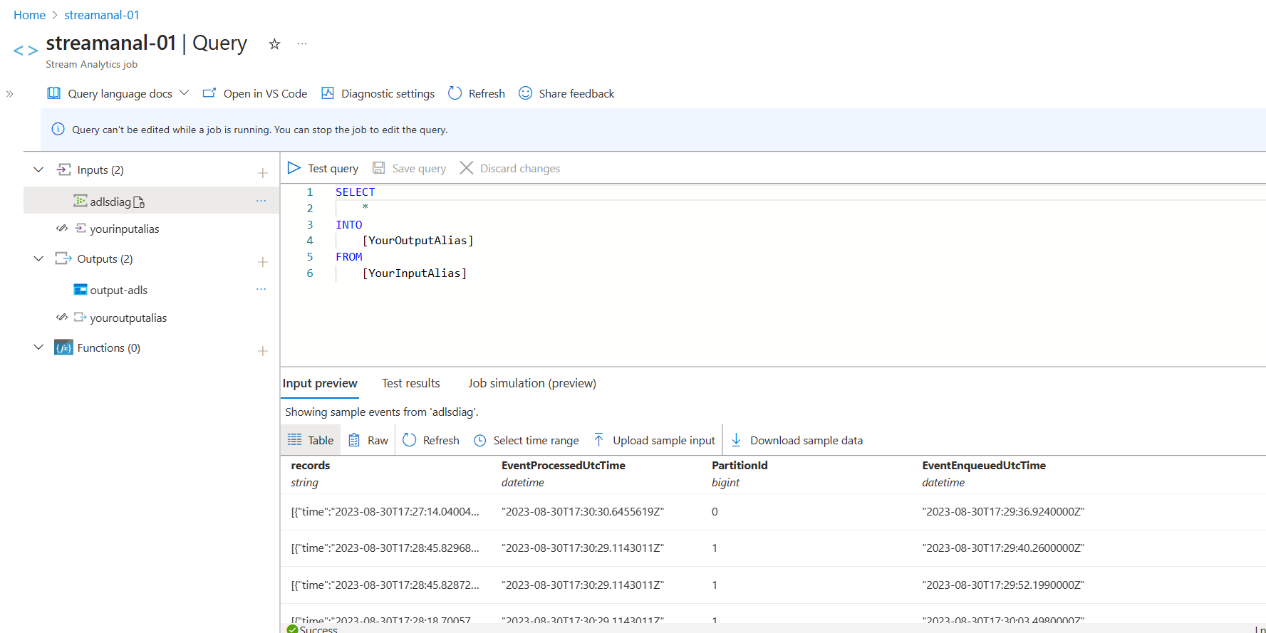

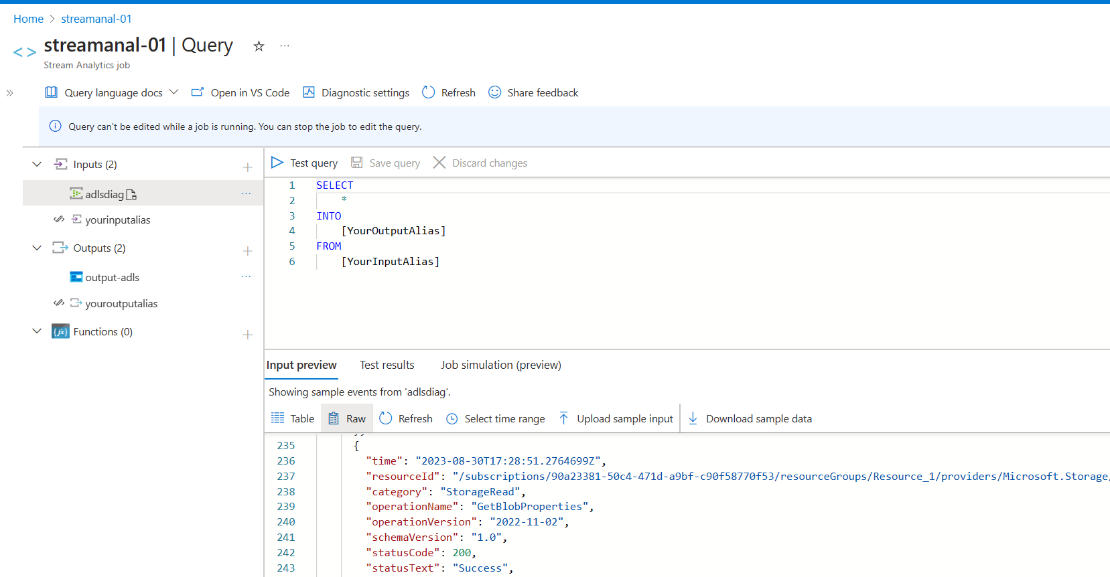

Use built In functions – get array elements

